First name Last name (& First name Last name)

TITLE OF THE THESIS
Subtitle

TITLE OF THE THESIS
Subtitle

First name Last name (& First name Last name)
Final projects
Term year (e.g. Spring 2020)
Degree programme name
Oulu University of Applied Sciences
ABSTRACT
Oulu University of Applied Sciences
Degree programme name, option name

Author(s):
Title of the thesis:
Thesis examiner(s):
Term and year of thesis completion: Pages: e.g. 24 + 5 appendices

The abstract is a concise, independent presentation that describes the thesis to the reader. It briefly describes the background, goals, methodology (theoretical background, research methods, materials used), the relevant results as well as the conclusions and development proposals. The abstract is written in complete sentences. The length of the text is one page, with a line spacing of 1.

Keywords: List 3–7 keywords that describe your thesis. Tools that you can use include the Finto thesaurus and ontology service (http://finto.fi/fi/), the General Finnish Thesaurus (YSA) and professional glossaries and references.

ABSTRACT
Oulu University of Applied Sciences
Degree Programme in xxx, Option of xxx

Author(s):
Title of thesis:
Supervisor(s):
Term and year when the thesis was submitted:
Number of pages: e.g. 24 + 5 appendices (or 1 appendix)

Finnish theses also include an English abstract. It is not a direct translation from the Finnish abstract but is written to be understood internationally. The English abstract is an overall presentation on the thesis work, which is why the abstract can be shorter than the Finnish version and thus include less detailed information.
Use past tense when describing goals, methods and results. Use present tense when writing about things generally considered to be true. The Discussion section is also written in the present tense. Write in the passive form.
The length of the English abstract is one page with a line spacing of 1. Do not hyphenate the text.

If necessary, hyphenation for English text can be turned off as follows:
- Select
- Go to Page Layout – Paragraph and click on the button in the lower-right corner of the group (dialogue box key)
- In the Paragraph dialogue box, select the Line and Page Breaks tab.
- Select Formatting exceptions – Don't hyphenate.

CONTENTS
1 INTRODUCTION 6
2 STYLES 7
2.1 How to use styles 7
2.2 Styles required by the guidelines already incorporated in the template 8
2.2.1 An example of subtitles formatted according to the Heading 3 style 10
2.2.2 Example heading 10
3 TABLE OF CONTENTS 11
3.1 Updating the table of contents 11
3.2 Creating a table of contents 11
3.3 Adding appendices to the table of contents 12
3.4 Additional text in the table of contents 14
4 Page numbers 15
5 Tables and figures 16
5.1 Naming tables and figures with the Caption style. 16
5.2 Instructions on creating a basic table 16
5.3 Quick Table 17
6 Reference list instructions 19
7 Reference guidelines 20
7.1 Adding the name of an appendix 20
7.2 Adding appendices to the thesis 20
References 23
APPENDICES 23

INTRODUCTION
This thesis template helps in the writing process of the thesis. Using an existing template allows you to focus on the content. All formatting and specifications used in this template are based on the Oulu University of Applied Sciences thesis guidelines. The thesis guidelines are found in the Study guide. This thesis template already includes the following formatting:

- Styles (Table 1)
- Page settings:
  - Margins (left 3 cm, right 3 cm, top 2.5 cm, bottom 2.5 cm)
  - Paper size (A4)
- Header (Oulu UAS logo)
- Footer (1.5 cm from the page number to the bottom edge and a centred page number beginning with the Abstract page from page 3)
- Cover
- Title Page
- Abstract
- Abstract
- Table of Contents
- References
- Appendices

You can use this template by saving it under a different name. Click File – Save as and select where you want to save it. Open the file from where you saved it. You can edit and remove existing texts and readings from the template, such as change the heading names to fit your thesis and write your own contents. Be sure to use existing styles in formatting, since automatic indexing requires the use of heading styles.

STYLES
This thesis template already includes the required styles defined in the guidelines, which automatically apply the correct formatting for headings, for example. Styles and their descriptions are presented later in table 1.

How to use styles
Styles include a set of formatting features with predetermined fonts, sizes, text colours, spacings as well as the empty space between headings and paragraphs. Some styles also include margins and tints. Using styles makes it easier to write the thesis, as formatting settings do not need to be made manually.

Changing styles step-by-step:
- Select the part of the text where you wish to use a style.
- Home – Styles
You can open the Styles dialogue box by pressing on the lower-right corner of the Styles group (see pictures below). The same can be done by pressing Ctrl + Shift + Alt + S.
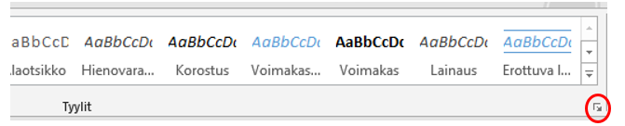
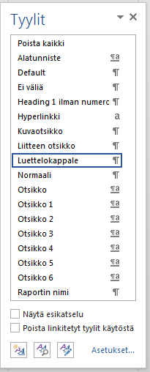
- Select the style you want from the panel.
- The text will now change according to the selected style. This allows you to quickly change any text to the required style.
- You can also select a new style from the list and begin writing new text. The text will automatically change according to the style.
- MS Word includes shortcut keys for some styles. The shortcut key for the normal style is Crtl+Shift+N, for example.
PLEASE NOTE! Since styles are chapter-specific, there needs to be a paragraph break (Enter).

Styles required by the guidelines already incorporated in the template
The next table lists and describes the styles already incorporated in the thesis template.

TABLE 1. Styles already incorporated in the template
Style | Using styles
Name of the report | Used for the cover and title pages when writing the NAME OF THE THESIS.
Information about the author | Used for the lower corner of the title page (Author, thesis etc.)
Abstract heading | Used for the heading ABSTRACT.
Abstract text | Used for the text in the abstract page.
Normal | Used for the body text and the words Author and Subtitle in the cover page.
Heading 1 | Used for the main headings.
Heading 2 | Used for the subtitle after Heading 1. There must be at least two subtitles under the main title (e.g. Chapter 2.1 must be proceeded by Chapter 2.2).
Heading 3 | Used for the subtitle after Heading 2. Three heading levels is usually enough. There must be at least two successive headings here as well.
Heading 4 | Used in the title CONTENTS in the table of contents page
Direct quote | Used for direct quotes, when the quotation is longer than three (3) lines.
Heading 1 without numbering. | Used for the REFERENCES title. This enables the title to be automatically included in the table of contents.
Caption | Used in the headings of figures and tables.
Appendix heading | Used to name appendices.

You can write a new top-level heading by selecting Heading 1 and writing your preferred heading. The heading has automatic numbering enabled and automatically starts a new page. If you require lower-level headings, select either Heading 2 or Heading 3. Before the lower-level headings, add a page break after the last heading by selecting Insert – Page Break (shortcut key Ctrl+Enter). You should never change a page simply by pressing Enter multiple times, as it makes formatting the report afterwards more difficult.

PLEASE NOTE: You can view all of the unprinted characters (spaces, paragraph breaks, page breaks, section breaks) that affect formatting by clicking the Show/Hide all button in the Paragraph group of the Home ribbon.

An example of subtitles formatted according to the Heading 3 style
These guidelines mainly include main titles and level two headings. An example of level three paragraphs is shown above.

Example heading
Here is an example heading. There must be at least two consecutive subtitles of the same level.

TABLE OF CONTENTS
The table of contents is titled TABLE OF CONTENTS and is formatted using the Heading 4 style. The table of contents shows the start page for each chapter. If changes are made to the text or headings, the table of contents must be updated accordingly. In addition to headings, the table of contents must include the start pages for references and appendices.

Updating the table of contents
In this template, the table of contents and the styles used in the table of contents are created and formatted in advance. How to update the table of contents:
- Right-click the table of contents and select Update Field. A pop-up window will appear.
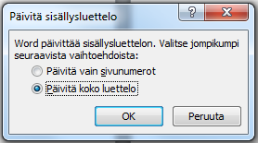
- Select either Update page numbers only or Update entire table. Press OK.
or
Another method: References – Table of Contents – Update table.

Creating a table of contents
If you accidentally delete the table of contents, you can create a new one by following the steps below.
- Select References – Table of Contents.
- Select Custom Table of Contents. Only this selection provides pre-defined formatting required in the guidelines to the table of contents. This function creates table of contents with your custom headings using heading styles.
- Select OK in the Table of Contents window.
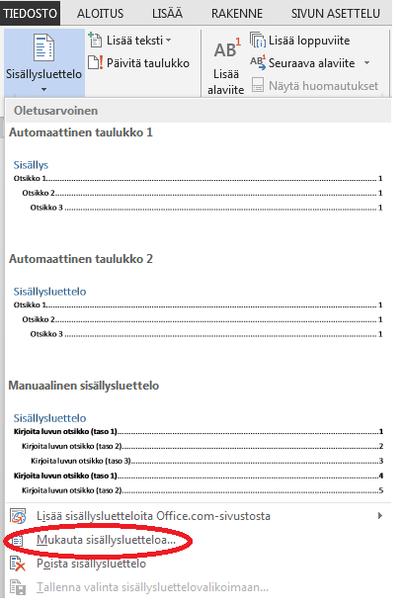

Adding appendices to the table of contents
If you have created an appendix list to the beginning of the Appendices section and have formatted its heading style, it will be automatically added to the table of contents. If there is no appendix list, the start page for appendices must be added to the table of contents manually. The following describes a method with which to add the start page for appendices to the table of contents. More information on the APPENDICES heading can be found in chapter 7.

Adding the Appendices heading and page number to the table of contents:
- Place the cursor to the last line in the table of contents and press Enter.
- Write APPENDICES.
- Align the right corner by selecting Home – Paragraph – Tabs.
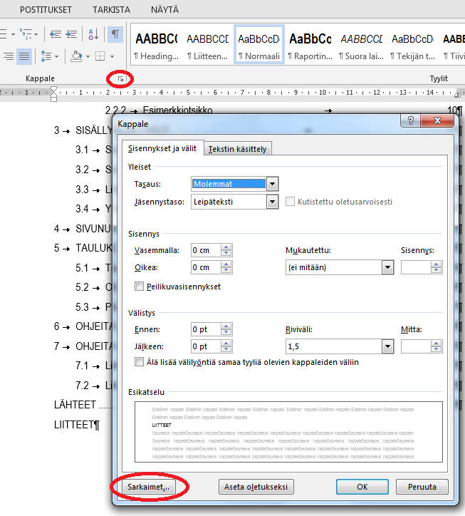
- Enter Tab stop position: 15 cm
Select Alignment: Right
Select Leader: 2……
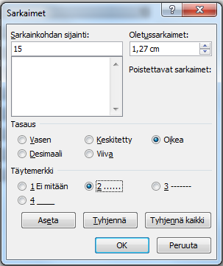
Click Set. Click OK.
- Make sure that the cursor is at the end of the word APPENDICES and press Tab.
(The Tab button is found to the left of the Q key.)
- Finally, enter the first page number for the Appendices page.
Below is an example of the APPENDICES heading in the table of contents.

PLEASE NOTE: If you update the table of contents, the APPENDICES heading will be deleted. Add the heading and page number again according to the method shown above.

Additional text in the table of contents
If there are unnecessary items in the table of contents, carry out the following procedure.
- Press and hold Ctrl and click on the unnecessary text. The cursor will move to the text in the document.
- Change the text style to Normal or the appropriate style.
- Update the table of contents (instructions above).

Page numbers
In this thesis template, the page numbers are already set to start with Page 3 in the Abstract page as according to the Oulu UAS thesis guidelines. The page number is centred to the lower corner of the page with a 1.5 cm spacing from the lower corner.

The page numbering has been set in the template as follows:
A. Add a section break to the end of the page, after which you want the page numbers to appear.
Move the cursor to the end of the title page and add a section break by selecting Page Layout – Breaks – Section Breaks – Continuous.
B. Break the connection between sections.
Click on the text in page 3 and then select Insert – Header & Footer – Footer – Edit Footer. Make sure that you are on part 2 in the footer. Make sure that Different First Page is not ticked. Break the connection between sections by selecting Header & Footer – Navigation and disabling Link to Previous . The button is turned off when it is grey.
C. Change the page numbering in the section where you want the page numbers to appear.
Make sure that you are on part 2 in the footer. Then, select Header & Footer, Page Number andFormat Page Numbers. Change the value in Start at: To 3 or select Continue from Previous Section.
D. Remove the page numbers from the sections where they should not appear.
Navigate to the Title page. Click on the footer and check that you are on the footer for section 1. Delete the page number from the footer by pressing Delete. Finally, select Close Header and Footer. Inspect whether the editing and removing of page numbers was successful.

PLEASE NOTE: If you accidentally removed the page numbers entirely from section 2, open the Abstract page footer and select Page Number, Bottom of Page and Plain Number 2.

Tables and figures
A style has already been formatted in this template, making it easier to name tables and figures.

Naming tables and figures with the Caption style.
The following provides instructions on how to add a numbered heading to a table or figure.
- Add a table or a figure and right-click on it (the table must be selected first). Select Insert Caption.
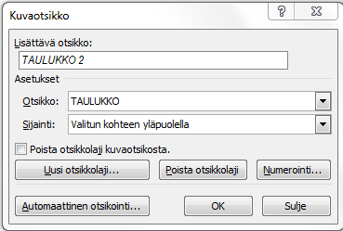

- Select the appropriate Note Caption from the drop-down menu: TABLE or FIGURE. If there are not any available, you can add a new label by selecting New Label.
- Select the correct location: Above selected item (tables) or Below selected item (figures).
- Add the table or figure name to the Caption field and click OK. The table or figure name must describe what is being presented in them.
- In terms of accessibility, an alternative text must be added to figures or tables. Instructions https://support.microsoft.com/fi-fi/office/vaihtoehtoisen-tekstin-lis%c3%a4%c3%a4minen-muotoon-kuvaan-kaavioon-smartart-grafiikkaobjektiin-tai-muuhun-objektiin-44989b2a-903c-4d9a-b742-6a75b451c669?ui=fi-fi&rs=fi-fi&ad=fi

Instructions on creating a basic table
This is how to create a basic table. You can utilise table 2 in your thesis by copying the table and changing its contents.

TABLE 2. A simple example table.
Subject matter 1 | Subject matter 2 | Subject matter 3 | Subject matter 4 | Subject matter 5
Text 1 | Chapter 1 | Text 2 | Text 3 | Text 4
Text 1 | Chapter 2 | Text 2 | Text 3 | Text 4
Text 1 | Chapter 3 | Text 2 | Text 3 | Text 4
Text 1 | Chapter 4 | Text 2 | Text 3 | Text 4

- Select Insert – Table and choose how many rows and columns you want.
- Click on the star icon in the left corner of the table (table selection)
- From the top menu, select Table Tools/Design – Borders - Borders – No Border.
- Select the first row of the table and add a Bottom Border and Top Border to it.
- Select the bottom row of the table and add a Bottom Border to it.
- The table is ready and you may add titles and text to it.
PLEASE NOTE: Removing borders does not affect the number of rows or columns in a table.

Quick Table
If you have designed the table to fit your needs and wish to use it again, you can save it as a Quick Table.
- Create a table and edit it as you see fit.
- Select the table. The easiest method is to click on the arrow icon in the upper-left corner.
- Go to Insert – Table – Quick Tables – Save Selection to Quick Tables Gallery.
- A pop-up window will appear. Enter the table name and any other information you want. Press OK.

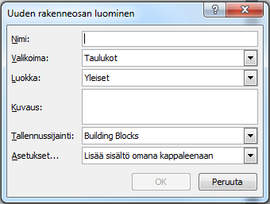

- The table has now been saved to the gallery and you can use it whenever you want by selecting the table from Insert – Table – Quick Tables.

Reference list instructions
For the REFERENCES heading, select Heading 1 without numbering. The references are added to the Reference list in alphabetical order using the Normal style. References are separated with an empty line. If necessary, you can add a line break to the reference by pressing Shift+Enter.

Reference guidelines
If there is a large amount of appendices, a list of all appendices can be added to the beginning of the Appendices section. The actual appendix includes the name, APPENDIX in capital letters and the appendix number. Each appendix begins from its own page.

Adding the name of an appendix
Proceed as follows:
- Navigate to the first line of the appendix page.
- Select the Appendix heading style.
- Enter the name of the appendix, beginning from the left corner.
- Select the text and add the (Strong) formatting to it.
- Move the cursor to the end of the name and press Tab once.
- Enter APPENDIX in capital letters and the appendix number

The word APPENDIX and the appendix number are always on the first line. If the name of the appendix is so long that the number continues to the next line, divide the name into two lines by pressing Enter. Navigate to the end of the first line and add APPENDIX and the appendix number as before.

Adding appendices to the thesis
You may require appendices to support your arguments in your thesis. Appendices are collections of useful information that do not need to be incorporated in the actual thesis. An appendix may be a table, research, list, calculation, background information etc.

There are many ways of adding appendices into a thesis. The following includes instructions on using screenshots. Screenshots can be sued to take a picture of a survey form made with the Webropol program and attach it to your thesis, for example.

A screenshot can be made using the

- Snipping Tool program, where you carefully select a part of the screen you wish to attach.
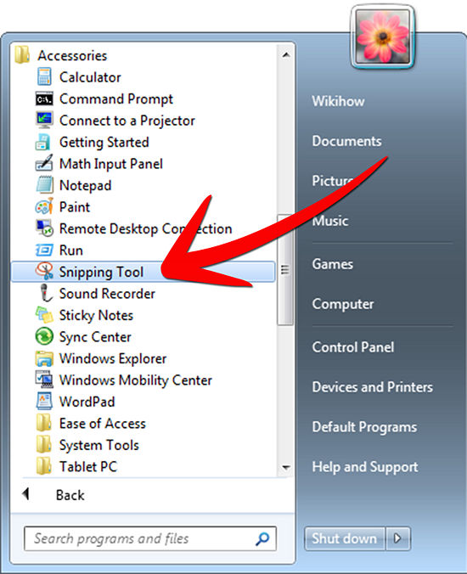

The fastest way to find the program is by typing its name into the search field of the Start Menu.

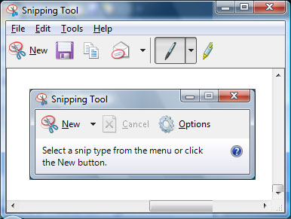

A pop-up window will appear and the screen will become brighter. Select the section you want.
OR

- You can press Print Screen or Prnt Scrn.

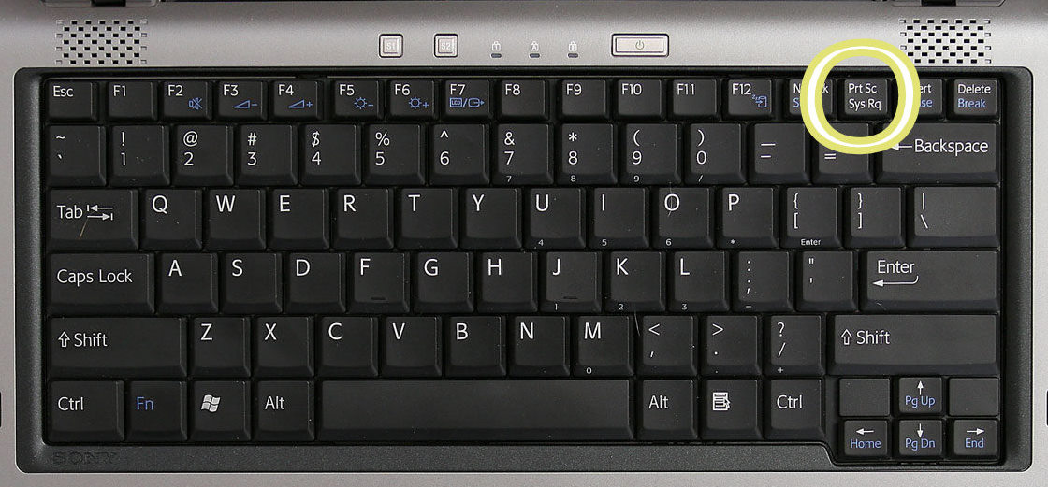

By pressing the Print Screen key, you take a picture of the entire computer screen currently open.

By pressing Alt + Print Screen, you only take a picture of the opened window.

To add a figure to your thesis, place the cursor to the desired section and press Ctrl + V
Or right-click on the desired section and select Paste.

If you do not want to add the entire screen to your thesis after pressing the Print Screen key, you can paste the picture into Paint and narrow it before pasting it to the thesis, for example. In these situations, using the Snipping Tool is easier, however.

References
E.g.
Bhatia, Manu 2018. Your Guide to Qualitative and Quantitative Data Analysis Methods. Search date 17.12.2019. https://humansofdata.atlan.com/2018/09/qualitative-quantitative-data-analysis-methods/.

Kallenbach, Theresa 2020. Narratives of urban mobility in Germany: On the threshold of a departure from the car-centered city?. Sustainability: science, practice, & policy, 16 (1), 197-207. Search date 23.9.2020. https://doi.org/10.1080/15487733.2020.1799625.

Kiefer Tina 2002. Understanding the emotional experience of organizational change: evidence from a merger. Academy of Human Resource Development, Advances in developing human resources 2002: 4, 39. Search date 23.9.2020. https://www.researchgate.net/publication/249628848_Understanding_the_Emotional_Experience_of_Organizational_Change_Evidence_from_a_Merger.

Rodger, Sylvia & Kennedy-Behr, Ann 2017. Occupation-centred practice with children: A practical guide to occupational therapistis. Second edition. Chichester: Oxford Wiley Blackwell.

APPENDIX NAME Appendix 1
If there are more than three appendices, a summary page for appendices is required. The heading of the summary page will then be APPENDICES, using the heading style of the appendix. The appendix names and numbers are written below using the Normal style,
E.g.
APPENDICES
Appendix name appendix 1
Appendix name appendix 2

